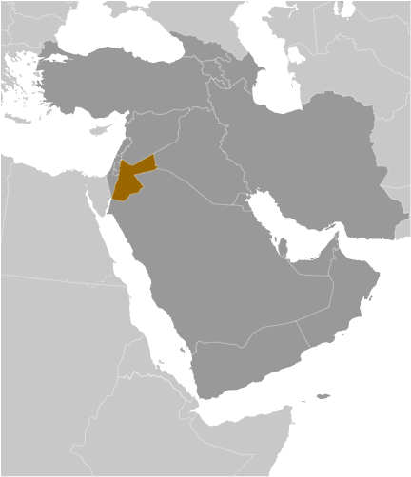
Jordan
- Jordan is located northwest of Saudi Arabia, between Israel and Iraq, with strategic access to water at the head of the Gulf of Aqaba. It is roughly the size of the state of Indiana. With roughly 6.5 million people, it ranks as the 105th largest country in the world. Jordan is under the reign of King Abdullah, a constitutional monarch, with a relatively well-educated population.
- With insufficient supplies of water, oil, and other natural resources, underlying the government’s heavy reliance on foreign assistance. Other economic challenges for the government include chronic high rates of poverty, unemployment, inflation, and a large budget deficit.
- Since assuming the throne in 1999, King Abdallah has implemented significant economic reforms, such as opening the trade regime, privatizing state-owned companies, and eliminating some fuel subsidies, which in the last decade spurred economic growth by attracting foreign investment and creating some jobs.
- Jordan ranks 32nd in the Heritage Foundation’s 2011 Index of Economic Freedom, considerably higher than most of its Arab neighbors. Its score is 1.0 point better than 2010, reflecting gains in half of the 10 economic freedoms including notable progress in business freedom. Jordan is ranked 3rd out of 17 countries in the Middle East/North Africa region.
- Starting a business in Jordan can be difficult – the World Economic Forum reports in 2012 that as many as 50 days and over 75 procedures are required – placing them in the bottom 50% for market efficiency.
- Bilateral free trade agreements with both the U.S. and the European Union provide for more open markets in communications, construction, finance, health, and transportation leading to a general improvement in Jordan’s economic infrastructure.
- High tariff barriers create problems for importing goods as well as making access to imported inputs at competitive prices difficult. The WEF ranked Jordan 98th of 132 countries in 2012 for their tariff rate – placing them in the bottom 30% of countries.
- Foreign ownership may not exceed 50% in the import/export market, construction, wholesale and retail trade. The government prohibits foreign investment in land transportation.
- In a 2012 WEF report, business executives surveyed claim inefficient government bureaucracy, access to financing, high tax rates, and corruption are the most problematic factors for doing business.
- Although Jordan scores in the top 30% of countries for the protection of property rights (including intellectual property), few patents are granted and they score low for their capacity for innovation (92 of 142 nations) and the quality of scientific research institutions (104 of 142 nations) in the WEF’s 2012 Global Competitiveness Report.
- Interest in property is recognized, enforced, and recorded through reliable legal processes and registries. The legal system protects the acquisition and disposition of all property rights.
- The Heritage Foundation reports that rule of law is not strongly supported by the judicial system, particularly due to growing corruption.
- The Heritage Foundation reports that public finance management and privatization have been key parts of the recent reform agenda, but overall economic freedom is limited by bureaucratic red tape, corruption, the judicial system’s vulnerability to political influence, and the inconsistent enforcement of regulations – inhibiting investment.
- The use of family, business, and other personal connections to advance personal business interests is seen by many Jordanians as a normal part of doing business.
- Transparency International’s 2012 Corruption Perceptions Index ranks countries based on how corrupt their private sector is perceived to be. Jordan ranks 4.5 out of 10 (10=Very Clean), leaving them 56th of the 183 countries ranked.
Specific Situation: Unrest in the Arab World
Jordan, one of America’s most important allies in the Middle East, was hit in late January 2011 by the waves of unrest that have spread across the Arab world in the wake of the revolution in Tunisia. On Feb. 1, King Abdullah II dismissed his cabinet and prime minister in a surprise move meant to calm street protests that have also been fueled by the country’s worst economic crisis in years.
Changing cabinets is not new for King Abdullah. In his 12 years on the throne, he has done so eight times. But this was the first time that he had done so in reaction to public pressure, seeking to undermine a growing protest movement across a broad spectrum of society and to pre-empt further unrest. It came after four weeks of unusual public demonstrations.”
Under growing pressure to accelerate political reform and genuine anticorruption measures, on Oct. 17, King Abdullah fired his government yet again. In a statement announcing the change, King Abdullah said, “We have accepted the resignation of Prime Minister Marouf al-Bakhit, taking into consideration the views of the various sectors of society as well as a letter we have received from the parliamentary majority.” Mr. Bakhit was seen by many as dragging his feet on political changes. His government also angered Jordanians with a new law that made it a crime, punishable by a steep fine, to falsely accuse someone of corruption.
Buffeted by the forces at play across the region — rising prices, a bulging underemployed youth population, the rapid spread of information and resentment, an unaccountable autocracy — Jordan is on edge.
“. . . Economic reform to bring Jordan in line with the global marketplace has tended to benefit the Palestinians, while the East Bankers — the core of the monarchy’s support — rely on the government payroll.”
“. . . The pro-American kingdom has struggled for years to balance a measure of democracy with the need to check a powerful Islamist movement and a large, restive Palestinian population.”
Source: Unrest in the Arab World. The New York Times. Saturday, October 22, 2011. http://topics.nytimes.com/top/news/international/countriesandterritories/jordan/index.htm (10-11)

Specific Situation: Caught in the Middle as Usual
"...complaints against corruption have become much louder. People who themselves have held senior positions of state are now saying, far more openly than before, that corruption “goes to the very top".... The sacking, last month, of the Central Bank governor was widely attributed to a threatened exposure of a case of money-laundering that might have strained relations between Jordan’s topmost elite and a Croesus-like prince from a Gulf emirate."
"...With 6m-plus people, Jordan has scant water, few natural resources and as yet no oil. It has long been poor, weak and buffeted by the region’s erratic political weather. It depends on the goodwill and generosity of its much beefier and richer neighbors such as Saudi Arabia and (until the fall of Saddam Hussein) Iraq, and, farther afield, on the assiduous backing of the United States and to a lesser extent Britain. The king looked askance at the fall of Hosni Mubarak in Egypt and nervously at the turbulence in Syria across his border. As long as the Israel-Palestine issue is unsolved, his Palestinian population will inevitably be accused of a dubious dual allegiance."
Source: Caught in the Middle as Usual. The Economist. Saturday, October 22, 2011. http://www.economist.com/node/21533452 (10/11)

