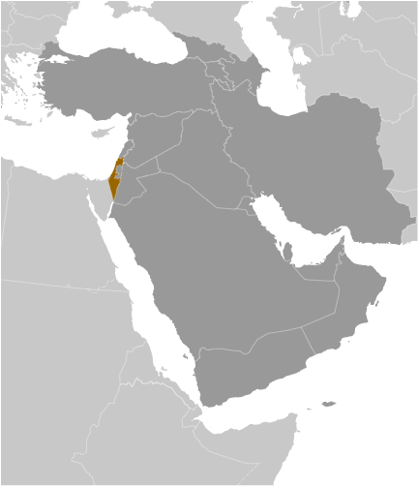
Israel
- Israel has a technologically advanced market economy. It depends on imports of crude oil, grains, raw materials, and military equipment. Cut diamonds, high-technology equipment, and agricultural products are the leading exports. Recent natural gas fields discovered off the coast, one of the largest discoveries in over a decade, have improved Israel’s energy security outlook.
- As a result of Israel’s dependency on foreign trade, they rank relatively high on the World Economic Forum’s 2012 Global Competitiveness Index – coming in 22nd out of the 142 nations currently ranked.
- In 2012, the World Economic forum ranks Israel in the top 20% of countries with the fewest procedures to start a business, but among the bottom 30% for the number of days involved in starting a business – at 34
- Their average tariff rate is moderate and places them in the middle of the pack – ranking 59th /142 countries. Business executives claim burdensome import procedures, high costs & delays caused by international transportation, and both tariff and non-tariff barriers are the most problematic factors for importing. These problems then result in high prices for imported inputs that affect their ability to export. Their main trading partners are the United States and the European Union.
- In 2012, The World Economic Forum identified the intensity of local competition to be high and venture capital is widely and easily available. Israel ranks 2nd globally for the availability of capital.
- Business executives surveyed by the World Economic forum claim an inefficient government bureaucracy, high tax rates, and an inadequate supply of infrastructure as the most problematic factors for doing business.
- Israel has a minimum wage and fair labor laws, and there are some price controls on items that are produced by monopolies or whose use is considered vital
- In 2012, the Heritage Foundation found Israel’s protection of property rights to be a cornerstone of their long-term economic expansion. The WEF reported in 2012 that Israel ranks 35th of 142 nations with regard to the protection of intellectual property.
- In 2012, the WEF ranked Israel first in the world for the quality of their scientific research institutions and 6th for their capacity for innovation. As a result almost 250 patents granted per million people – 4th highest in the world.
- Transparency International scored Israel 6.2 on a 7-point scale (7=being entirely independent) - for their judiciary being independent from the influences of government, citizens, and firms. This places them 12th compared to the other 142 nations surveyed.
- Business Executives surveyed by the World Economic Forum in 2011 rate the level of public trust in the ethical standards of politicians within Israel relatively low at 3.2 out of 7 (7=very high.)
- It is relatively easy to obtain information regarding changes to government policies/regulations that affect business activities. In 2012, the WEF ranked Israel in the top 40% globally for their transparency of government policymaking.
- They are recognized for relatively low corruption in their regulatory environment. Business executives, surveyed by the WEF in 2011, reported that police services are only somewhat reliable to enforce law and order within the country. Israel ranks 53rd out of 142 countries.
- Transparency International Corruption Perceptions Index ranks countries based on how corrupt their private sector is perceived to be. Israel ranks 5.8 out of 10 (10=Very Clean) placing them 36th of the 183 countries ranked.
- Israel ranks in the 76th percentile for Rule of Law in measurements by the Transparency International that attempt to capture the perceptions of the extent to which agents have confidence in and abide by the rules of society, and in particular the quality of contract enforcement, property rights, the police, and the courts, as well as the likelihood of crime and violence.
Israel Facing Blackouts as Natural Gas Shortage Looms

By Sara Toth Stub, July 11, 2012

JERUSALEM--Israel is likely facing rolling electricity blackouts this summer as a heat wave and natural-gas shortage could result in energy demand outstripping supply, the state-run Israel Electric Corp. Ltd. said Wednesday.
The electricity shortage results from both a shortage in natural gas provisions and lack of sufficient infrastructure, including power stations, the electric company said, although any blackouts would only likely last for one hour each day, and occur in one geographic region at a time, the state company said. Moreover, economists contacted by Dow Jones Newswires Wednesday said blackouts would not likely impact the economy, with the problem only being short-term. Since Israel's Tamar natural gas field is scheduled to start production next year, the country will have enough gas to be self-sufficient for up to 30 years, according to Ayelet Nir, chief economist at Psagot Investment House in Tel Aviv.
"It's important that we have these new discoveries [Tamar, which contains 9 trillion cubic feet of natural gas, and the neighboring Leviathan field, which contains 17 trillion cubic feet of natural gas] coming online," said Roni Biron, senior analyst at UBS Israel. "It should allow Israel to be self-sufficient for gas consumption for a number of decades."

The Tamar reserve, off the coast of northern Israel about 1,700 meters deep in the Mediterranean, was discovered to contain large, commercial amounts of natural gas in 2009. The Tamar field was second only to Israel's other large gas field, Leviathan, in terms of natural gas fields discovered in the last decade, said Amit Mor, CEO of Eco Energy Ltd., an Israeli strategic and financial consulting firm for the energy sector. "The connection of the Tamar field to the electricity grid is a major step in Israel's energy independence," Mr. Mor said. By 2016, Israel is expected to rely on natural gas for 70% of its electricity generation, up from its current level of 40%, Mor said. But Israel will face the challenge of keeping the Tamar field, which will be its only source of gas until production can start at Leviathan some years later, secure from geopolitical risks, as it is located just 10 miles offshore from Gaza, Mor said. Noble Energy Ltd. (NBL) owns 36% of the Tamar field. Delek Group Ltd. (DLKGF, DLEKG.TV) subsidiaries Avner Oil Exploration (AVNRL.TV) and Delek Drilling (DEDRL.TV) each own 15.6%, with several other companies holding the remaining stake.

Meanwhile, Israel Electric Corp has called on consumers to conserve power to help avert blackouts. Since early 2011, Israel's natural gas supply from Egypt has been interrupted dozens of times due to a series of attacks on the pipeline in the Sinai peninsula, a problem exacerbated by the fall of former president Hosni Mubarak's regime. This has forced the electric company to increase prices so it can buy more expensive sources of fuel, including diesel. Indeed, this week the electric company raised $2.9 billion in a bond issue to ensure positive cash flows amid the shortage of gas. The electric company also lacks enough power stations that can use alternative fuels, such as diesel, the company said, meaning that the gas-only stations can't operate fully during a gas shortage. The electric company is currently converting at least one major power station that runs on natural gas to also run on diesel, in addition to building more power stations.

http://online.wsj.com/article/BT-CO-20120711-710369.html

