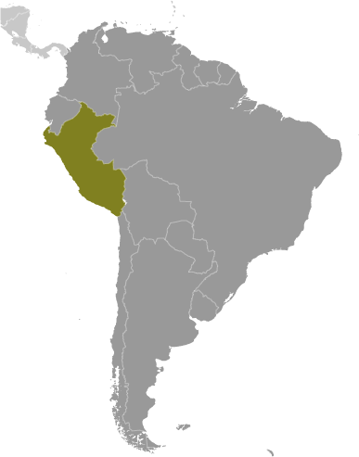
Peru
- Located on the western coast of Latin America between Chile, Ecuador, and Bolivia, over 29 million people live in the country of Peru – which is slightly smaller than the state of Alaska. Political instability was the norm until the election of Alan Garcia Perez in 2006 brought economic reforms that have resulted in robust economic growth. The 2011 election of Ollanta Humala Tasso has continued these reforms.
- Despite Peru’s strong macroeconomic performance, dependence on minerals and metals exports and imported foodstuffs, subjects the economy to fluctuations in world prices. Poor infrastructure hinders the spread of growth to Peru’s non-coastal areas.
- As a result of their lack of infrastructure, the World Economic Forum scored Peru 4.2 out of 7 on their 2012 Global Competitiveness Index – ranking them 67th of 142 nations.
- Peru is ranked 42nd on the Heritage Foundation’s 2012 Economic Freedom Index, and 6th of the 29 Latin American countries.
- While requiring only six procedures to start a business, bureaucratic inefficiency results in this taking over 90 days – resulting in their being ranked 91st of 142 nations, by the World Economic Forum in 2012.
- Recent trade agreements with the U.S., European Union, and the Asian market, combined with reasonable tariff rates have resulted in improved trade relations. Although high costs & delays associated with domestic transportation inhibit the process.
- The WEF ranked Peru 20th of 132 nations ranked for their openness to foreign participation in 2012 as a result of encouraging foreign ownership, the hiring of foreign workers, and the availability of trade finance.
- Businesses do consider corruption and bureaucratic inefficiency as some of the primary obstacles to doing business. Compared to other countries in the world, the WEF reports that Peruvians rank the ethical behavior of firms at only 3.7 on a 7-point scale (7=among the best in the world.)
- Transparency International’s 2012 Corruption Perceptions Index ranks countries based on how corrupt their private sector is perceived to be. Peru scores only 3.4 out of 10 (10=Very Clean.)
- Peru ranks low (in the 31st percentile) for Rule of Law in measurements by Transparency International in 2012 that attempt to capture the perceptions of the extent to which agents have confidence in and abide by the rules of society, and in particular the quality of contract enforcement, property rights, the police, and the courts, as well as the likelihood of crime and violence.
- Although the Peruvian economy has gained in economic freedom over the past five years, the weak rule of law and corruption continue to undermine prospects for long-term economic development.
- With a score of only 2.6 on a scale of 1-7 (7=entirely independent), Transparency International ranks Peru 119th of 142 countries for their Judicial Independence. Accelerating judicial reforms along with streamlined public administration will help sustain economic growth and improve living standards.
- Peru is ranked 114th of 142 nations for the reliability of police services. Since 2008, Peruvian law enforcement has worked with political and civil society organizations to reduce opportunities for corruption, but Peruvians remain skeptical of the government’s commitment to eliminating high-level graft. Enforcement of intellectual property rights is weak.
- Enforcement of intellectual property rights is week. Few patents are granted and the quality of scientific research institutions is low, resulting in little capacity for innovation.

Peru Declares State of Emergency to Quell Violent Mining Protests

By Ryan Dube
Published July 04, 2012/Dow Jones Newswires

Peru's government declared late Tuesday a state of emergency in three provinces in Cajamarca region following violent protests against Newmont Mining Corp.'s (NEM) Minas Conga copper and gold project. The 30-day state of emergency, which suspends civil liberties like freedom of assembly, took effect Wednesday and is aimed at restoring order in the provinces. Three people were killed Tuesday and 21 others injured during clashes between police and protesters.

Resolving the conflict over Minas Conga is seen as a test of the government's ability to resolve other social conflicts that have delayed investment projects in Peru's mining sector. Companies have lined up investment projects worth more than $53 billion in the next few years. Opponents of Minas Conga want the project to be canceled, citing concerns about its potential impact on the water supply. Protests have been led by Gregorio Santos, the president of Cajamarca's regional government, as well as civil-society groups. Minas Yanacocha, the company developing Minas Conga, called for dialogue to resolve the dispute and renewed its commitment to Cajamarca. "We express our deepest condolences to the families of the three people that died," Yanacocha said in a statement.

While protests against mining projects in Peru often turn deadly, it is the first time fatalities have been reported during protests against Minas Conga. Minas Conga, which will require an investment of about $5 billion, was put on hold late last year due to the opposition. The company said this week that it had started environmental work to prepare sites for the construction of water reservoirs, which would increase the supply of water to the local population. Minas Conga is expected to have an average annual output during the first five years of 580,000 to 680,000 ounces of gold and 155 million to 235 million pounds of copper. Production is scheduled to start in 2017.

http://www.foxbusiness.com/news/2012/07/04/peru-declares-state-emergency-to-quell-violent-mining-protests/?utm_source=feedburner&utm_medium=feed&utm_campaign=Feed%3A+foxbusiness%2Flatest+%28Internal+-+Latest+News+-+Text%29

