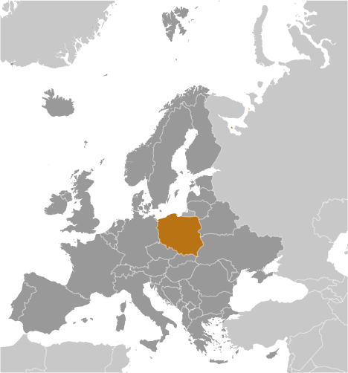
Poland
- Poland has maintained a robust economy during the recent global recession and after 4.4% growth in 2011, the CIA World Factbook records their GDP at $781 billion. Per capita GDP is $20,600, below the EU average. Unemployment remains high (12.4%) relative to other EU members, but inflation remains stable (4 %.)
- Attempts to streamline business start-up procedures have resulted in gains, but it takes slightly more than the average of 30 days to launch a business. The WEF ranks Poland 75th and 70th (of 134 nations) for the number of procedures and time required to start a business. The cost of completing licensing requirements has been cut almost in half.
- Business executives surveyed by the WEF in 2012 list tax regulations, inefficient government, and an inadequate supply of infrastructure as the most problematic factors for doing business.
- Air pollution, a result of coal-fired power plants, the damage resulting from acid rain along with contamination of industrial and municipal water sources, and problems with hazardous waste disposal present challenges for Poland to bring their environmental codes up to EU standards. This will result in substantial cost to business and government.
- An inefficient commercial court system, a rigid labor code, bureaucratic red tape, a burdensome tax system, and persistent low-level corruption keep the private sector from performing up to its potential.
- While a member of the European Union, Poland does not use the Euro currency. While their trade weighted average tariff rate is low (1.4%) as in other members of the EU, non-tariff barriers are still substantial. In 2012, the WEF scored Poland 70 on a scale of 0-100 (100 = worst.).
- While foreign and domestic investors are generally treated equally, certain areas of investment require government approval and the regulatory system is not particularly efficient.
- Poland ranks the as 64th freest country in the world on the Heritage Foundation’s 2012 Economic Freedom measures, slightly improved from 2011 as a result of attempts to control corruption, but fiscal discipline remains a problem.
- Poland has created a dynamic environment for entrepreneurs, slightly improving their capacity for innovation and the quality of their scientific research institutions. Poland has a competitive advantage with regard to the availability of venture capital – ranking 50th of 134 nations.
- Piracy of intellectual property continues despite government efforts to improve protection. In 2012, the WEF ranked Poland 61st of 142 nations for their protection of intellectual property.
- In 2012, Transparency International scored Poland 4.3 on a scale of 1-7 (7=entirely independent) for the independence of their judiciary. Poland ranks 53rd of the 143 nations ranked.
- Poland ranks in the 69th percentile for Rule of Law in measurements by the Transparency International (2102) that attempt to capture the perceptions of the extent to which agents have confidence in and abide by the rules of society, and in particular the quality of contract enforcement, property rights, the police, and the courts, as well as the likelihood of crime and violence. Bribery and abuse of public office are punishable under the criminal code, but systemic corruption remains a cause for concern.
With a little help from Google, Polish startup accelerator GammaRebels shifts into second gear
by Robin Wauters
26th June 2012

[GammaRebels in partnership with Google for Entrepreneurs is a startup accelerator program for technology entrepreneurs. It is an intensive 3 month long program held in Krakow.]

Polish startup accelerator program GammaRebels has found a new partner in Internet giant Google, which is teaming up with the business builder founded by VC firm hardGAMMA Ventures to help launch and support new startups. Now in partnership with Google for Entrepreneurs, the GammaRebels accelerator program is open to all startups from Poland and abroad. The venture will house startups in a new, specially developed space in Kraków.

Explains hardGAMMA Ventures partner Krzysztof Kowalczyk: “By executing the program in partnership with Google, startups would be advised by a broader group of acclaimed specialists and experienced mentors, working actively in the new technology sector.” Wojtek Burkot, Google’s Krakow Engineering Center Head, adds: “Google began as a startup in a garage and remains a startup at heart. The goal for us is to create a central meeting point for local tech startup community and help Krakow emerge as an entrepreneurial hub.”

Through GammaRebels, usually a 3-month long program, hardGAMMA Ventures invests up to 12.000 euros ($15,000) in exchange for a 10% stake in the participating tech startups. The first edition of GammaRebels started in August 2011. For this year, 2 dedicated editions in Kraków are planned, although the dates haven’t been set in stone yet. Google will help GammaRebels get set up in Poland’s second-largest city, and also commit to providing hands-on training and mentorship to help entrepreneurs in the program leverage the Web and Google products. In addition, Google will host events and programs for the broader startup community at the Google Kraków office in collaboration with GammaRebels.

http://thenextweb.com/eu/2012/06/26/with-a-little-help-from-google-polish-startup-accelerator-gammarebels-shifts-into-second-gear/

