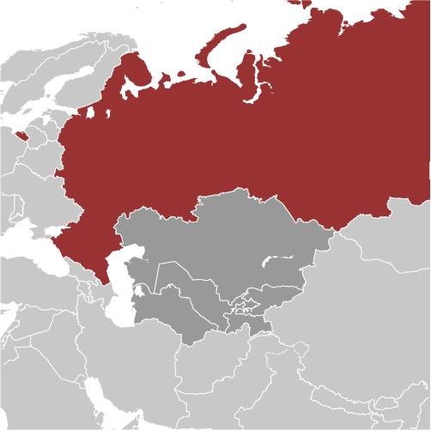
Russia
- After undergoing significant changes since the collapse of the Soviet Union, Russia has moved toward a more market-based and globally-integrated economy. Most industry was privatized in the 1990’s except for energy and defense related sectors. The state asserts a dominant role in the extractive industries and depends heavily on exports of natural resources.
- Russia surpassed Saudi Arabia in 2011, becoming the world’s leading oil producer. They also hold the world’s largest natural gas reserve and the second-largest coal reserve. This places them at the mercy of fluctuating global resource prices which have resulted in out-of-control government spending.
- The Russian government has demonstrated little if any commitment to economic reform in recent years, and The Heritage Foundation’s 2012 Economic Freedom Index gives them a of 50.5 and ranks Russia the 144th “freest” of 179 countries. They remain stuck at the lower end of the “mostly unfree” category.
- Tariff duties and layers of complex non-tariff barriers significantly increase the cost of trade. The World Economic Forum ranks Russia 132nd of 139 countries for the burden of their customs procedures. Extensive state interference in the economy weakens private-sector dynamism.
- The World Economic Forum ranks Russia 38th of 139 nations for their capacity for innovation and 53rd for the quality of their scientific research institutions.
- Russia’s legal framework is not up to the needs of a modern market economy. The rule of law is not strongly maintained across the country. In 2012, the Heritage Foundation gave Russia a score of 25 out of 100 for their protection of property rights and 21 out of 100 for their freedom from corruption. The court systems is identified as being so inefficient and corrupt that outside settlement and arbitration is the norm.
- In 2012, Transparency International scored Russia 2.6 on a scale of 1-7 (7=entirely independent) for their Judicial Independence. This places them 123rd of the 142 nations ranked. Judicial corruption is extensive. In 2012, the Heritage Foundation considers their judiciary “neither independent of political pressure nor consistent in applying the law.”
- Transparency International ranks Russia in the 69th percentile for “Rule of Law” - Transparency International’s measurements attempt to capture the perceptions of the extent to which agents have confidence in and abide by the rules of society, and in particular the quality of contract enforcement, property rights, the police, and the courts, as well as the likelihood of crime and violence.
- In their 2012 report, the World Economic Forum reported that Russia scored 3.2 out of 7 for the payment of bribes and 2.6 out of 7 for their favoritism in decisions of government officials – they rank in the bottom 25% in both categories. Organized crime rates are high and Russia ranks in the bottom 10% for the reliability of police services.
- Pervasive corruption and limited respect for property rights undermine the rule of law, increasing uncertainty and investment risk. In 2012, the World Economic Forum ranked Russia 128th of 139 countries for their protection of property rights. Intellectual property protections didn’t fare much better – Russia ranked 119th of 139 nations.
Russian Students Visit Purdue
July 17, 2012
WEST LAFAYETTE, Ind. - A group of Russian undergraduate students are spending this month at Purdue University to expand their understanding of how to take a creative idea and turn it into a viable business venture.
Eleven students from the Yegor Gaidar Summer Leadership Program will tour Purdue's research facilities, technology transfer offices and business incubators. Meetings are planned to discuss potential collaborations with researchers in Discovery Park and elsewhere on campus, as well as graduate students, faculty members and entrepreneurs at Purdue Research Park.
The students also will work in teams on a business case to commercialize a new or enhanced product. Teams will determine the best way to establish a startup by developing a business plan, building a management team, identifying capital needs and creating a marketing strategy.
"This entrepreneurship program is a great opportunity for the Russian undergraduate students to experience entrepreneurship in the United States," said Joseph Hornett, senior vice president, treasurer and COO of the Purdue Research Foundation. "In addition, the three-week program represents an important collaboration among Purdue and Russian students and leaders to learn best business practices from each other."
…"The enthusiasm of these young Russian students is contagious, as they access the many resources focused on entrepreneurship here at Purdue and through the Purdue Research Park," said Alan H. Rebar, executive director of Discovery Park and senior associate vice president for research at Purdue. "We are seeing benefits in terms of large university global partnerships with Russia. They learn from us and we learn, as well, from these entrepreneurially minded Russian students."
The students' business plan project is modeled after the Purdue Research Park Entrepreneurship Academy, a program established in 2007 that introduces young people to the world of entrepreneurship. The program is operated by the Purdue Research Foundation and managed by Tim Peoples, director of Purdue Technology Centers of West Lafayette, and Juliana Spiker, academy coordinator.
"The world is getting smaller and smaller, and this has provided Purdue with a terrific opportunity for exchanging information and creating substantive partnerships," said Candiss Vibbert, associate director for the Discovery Park Office of Engagement who has worked with the EURECA project since its inception in 2009.
A new Russian federal law gave Russian universities control over their intellectual property in 2009, allowing for the creation of small companies on campuses. This action dovetails with the U.S. Bayh-Dole Act, signed into law in 1980.
The Yegor Gaidar Summer Leadership Program is a joint project between the Yegor Gaidar Foundation and U.S. Russian Foundation, designed to assist Russian undergraduate students with the knowledge, skills and practical experience in the area of economic and business development, with a focus on economics and entrepreneurship.
The U.S. Russia Foundation is working to support the long-term economic development of Russia's economy, working closely with the Russian government and leading Russian institutions. In this way, the foundation seeks to build strong ties between the United States and Russia.
In addition to this program, the U.S. Russia Foundation is funding the Enhancing University Research and Entrepreneurial Capacity, or EURECA, program. In addition to Purdue, that collaboration includes the universities of California-Los Angeles, Maryland and Washington, and a consortium of program operators.
Purdue projects through EURECA, which was launched in 2009, are focusing on ways to determine the value of university-led intellectual property, faculty and student exchanges, joint incubators and technology centers, venture capital participation in student startups, technology transfer certification programs, and incubation of professional tech-transfer associations.
http://www.insideindianabusiness.com/newsitem.asp?ID=54680

