LESSON 4: TRADE AND JOBS
(NAFTA as a Case Study)
Economic Concepts:
- Exports
- Free trade
- Human capital
- Imports
- Labor markets
- Productivity
- Trade deficit
- Voluntary exchange
Content Standards:
Standard 5: Students will understand that: Voluntary exchange occurs only when all participating parties expect to gain. This is true for trade among individuals or organizations within a nation, and among individuals or organizations in different nations.
- Students will be able to use this knowledge to: Negotiate exchanges and identify the gains to themselves and others. Compare the benefits and costs of policies that alter trade barriers between nations, such as tariffs and quotas.
Benchmarks, Grade 12: At the completion of grade 12, students will know
- A nation pays for its imports with its exports.
- When imports are restricted by public policies, consumers pay higher prices and job opportunities and profits in exporting firms decrease.
Standard 6: Students will understand that: When individuals, regions, and nations specialize in what they can produce at the lowest cost and then trade with others, both production and consumption increase.
- Students will be able to use this knowledge to: Explain how they can benefit themselves and others by developing special skills and strengths.
Benchmarks, Grade 12: At the completion of grade 12, students will know
- Two factors that prompt international trade are international differences in the availability of productive resources and differences in relative prices.
- Individuals and nations have a comparative advantage in the production of goods or services if they can produce a product at a lower opportunity cost than other individuals or nations.
- Comparative advantages change over time because of changes in factor endowments, resource prices, and events that occur in other nations.
Standard 13: Students will understand that: Income for most people is determined by the market value of the productive resources they sell. What workers earn depends, primarily, on the market value of what they produce and how productive they are.
Benchmarks, Grade 12: At the completion of grade 12, students will know
- Changes in the structure of the economy, the level of gross domestic product, technology, government policies, and discrimination can influence personal income.
- Changes in the prices for productive resources affect the incomes of the owners of those productive resources and the combination of those resources used by firms.
Standard 15: Students will understand that: Investment in factories, machinery, new technology, and the health, education, and training of people can raise future standards of living.
- Students will be able to use this knowledge to: Predict the consequences of investment decisions made by individuals, businesses, and governments.
Benchmarks, Grade 12: At the completion of grade 12, students will know
- Economic growth creates new employment and profit opportunities in some industries, but growth reduces opportunities in others.
- Investments in physical and human capital can increase productivity, but such investments entail opportunity costs and economic risks.
Lesson Overview
Economic change is not easy. Whenever economies change, even if the overall change is positive, some individuals suffer losses. Economist Joseph Schumpeter characterized the process of economic change as “creative destruction,” noting that the shifting of resources into different uses is a disruptive process. When trade increases, as it did through the creation of freer trade zones like the European Union and NAFTA, wealth increases. The outline below provides a case study of NAFTA as an example of the impact of increasing trade on jobs and employment and includes an update and a chance for students to make inferences about the economic impact of the 2018 USMCA agreement. The classroom activity following the outline helps students to identify groups and individuals who may benefit and those who may be left out of the wealth-creation that accompanies increasing international trade.

Key Points:
Background summary
- NAFTA, the North American Free Trade Agreement first envisioned by Mexican President Carlos Salinas, was signed by Salinas, U.S. President Clinton, and Canadian Prime Minister Mulroney, taking effect January 1, 1994.
- The free trade agreement, itself, was a one page document that committed Canada, Mexico, and the United States to allowing free movement of goods and services across the borders separating the three nations.
- The complete NAFTA document comprised over 2000 pages, the majority detailing the exceptions to the free movement of goods and services.
    - Some of the exceptions were permanent, but most were scheduled to be phased out over a 5 to 20 year period.
    - Terms were implemented gradually through January 2008 eliminating most tariffs between the three countries (focused largely on agriculture, textiles, and automotive manufacturing).
  - There was bipartisan backing—negotiated by Republican President George H.W. Bush, passed by a Democratic-controlled Congress, and implemented under Democratic President Bill Clinton.
- NAFTA negotiations began in 1991 with the hope of integrating Mexico with the high-wage economies of the US and Canada.
  - Opponents of the agreement, balked at the possibility fearing the wage differential would lead to the infamous “Giant Sucking Sound” of US jobs leaving the country.
- In the 1990s, the Mexican economy was just 5% the size of the U.S. economy, so its ability to create an overall impact on the U.S. was small. (See Visual #1)
- Most barriers to trade between the U.S. and Mexico had been systematically dismantled prior to NAFTA:
- Mexico began a substantial program to reduce tariffs in the late 1980s, dropping average weighted tariff rates from 34% in 1985 to just 4% in 1991-92.
- The U.S. had always pursued a relatively free trade policy with Mexico.
- Since Mexico is a member of the World Trade Organization, it has Most Favored Nation status with the U.S. and is automatically entitled to the lowest U.S. tariff rates, regardless of NAFTA.
- Additionally, Mexico has had a special trade status with the U.S. since the inception of the Maquiladora Program in the mid-80s.
- Maquiladores, manufacturing plants located in northern Mexico, specialized in assembly operations for products to be exported from Mexico to the U.S. with special free trade rights.
- Mexico allowed the duty-free importation of manufacturing inputs; the maquiladoras assemble the goods which were then exported back to the U.S. without tariffs or duties.
- By 1990, well before NAFTA negotiations started, there were 281 plants, employing over 125,000 Mexicans. (See Visual #2)
- The implication is that trade and investment flows between the U.S. and Mexico were successful, growing, and bound to continue increasing even without NAFTA.
- Within the larger picture of relatively open trade between the U.S. and Mexico, NAFTA had two specific purposes:
- 1st – NAFTA represented a commitment, particularly by Mexico, to maintain current free trade policies into the future.
  - The U.S. had been engaged in a policy of reducing world trade barriers in most sectors, and signing NAFTA really implied no change.
    - Because of the size differentials in the two economies, signing NAFTA was far less important to the U.S. than to Mexico.
      - In 1999, for example, U.S. total goods imports from Mexico were a mere 1.1% of U.S. GDP, while those same goods (exported from Mexico) were slightly over 20% of Mexican GDP.
  - Mexico had, at various times in the past, pursued strong anti-trade policies, and signing NAFTA was a commitment not just to be open now, but to stay open to trade in the future.
    - Mexico knew that such a commitment was necessary if it was to continue to attract U.S. investment, which was leery of the uncertainty suggested by Mexico’s trade history.
- 2nd – NAFTA signified intent by the United States to open international trade in sectors that had historically been heavily protected.
- In line with a consistent, historical policy of reducing trade barriers, the U.S. had begun to address those sectors of the economy that had been difficult to open due to entrenched special interests: agriculture, textiles, and transportation.
- Large-scale, multi-national negotiations under the auspices of the World Trade Organization proved contentious and unsuccessful.
- U.S. policy-makers found it easier to pry open these sectors through local negotiations resulting in regional trade agreements.
- Much of the post-NAFTA resentment was directed toward reductions in agricultural, apparel-manufacturing, and transportation trade barriers.
- For example, historically, Mexican trucks had been prohibited from transporting goods produced in Mexico (even in the maquiladoras) to their final destinations in the United States. NAFTA provisions were to phase out this restriction within 5 years after signing.
- The Clinton administration, under pressure from U.S. truckers, prevented this provision from taking effect.
- An excellent reading as the basis for a classroom discussion is Russell Roberts’ article, “How Safe is That Trucker in the Window,” which can be found online at: http://russroberts.info/article/how-safe-is-that-trucker-in-the-window/ (3/25/19)
- In the early years of the agreement the magnitude of the agreement was difficult to measure. The first 7 years after the passage of NAFTA constituted the majority of one of the longest economic expansions in U.S. history, with high economic growth rates, low rates of unemployment, and very low inflation.
- By 2001, the two sectors most directly affected by NAFTA were agriculture and apparel manufacturing.
        - These sectors experienced tariff reductions of 68% on goods exported to Mexico and 48% on goods coming into the U.S.
        - Trade volume between the U.S. and Mexico increased approximately 16% in the decade after NAFTA was signed.
- (However, it should be noted that this is not a 16% increase in total trade volume for the U.S., as some was merely a shift in apparel manufacturing from Asia to Mexico as a result of tariff reductions.)
- With now a two decade record, the positive impact of NAFTA is clear and has generated substantial new opportunities for the US—including workers, farmers, consumer, and businesses.
- Trade with Canada and Mexico supports nearly 14 million American jobs, and nearly 5 million of these jobs are supported by the increase in trade generated by NAFTA.
  - The expansion of trade unleashed by NAFTA supports tens of thousands of jobs in each of the 50 states—and more than 100,000 jobs in each of 17 states.
- Since NAFTA entered into force in 1994, trade with Canada and Mexico has nearly quadrupled to $1.3 trillion, and the two countries buy more than one-third of U.S. merchandise exports.
- The United States ran a cumulative trade surplus in manufactured goods with Canada and Mexico of more than $79 billion over the past seven years (2008-2014). For services, the U.S. surplus was $41.8 billion in 2014 alone.
- U.S. manufacturers added more than 800,000 jobs in the four years after NAFTA entered into force.
  - Canadians and Mexicans purchased $487 billion of U.S. manufactured goods in 2014, generating nearly $40,000 in export revenue for every American factory worker.
- U.S. agricultural exports to Canada and Mexico increased by 350%.
- With new market access and clearer rules afforded by NAFTA, U.S. services exports to Canada and Mexico tripled, rising from $27 billion in 1993 to $92 billion in 2014.
- Canada and Mexico are the top two export destinations for U.S. small and medium-size enterprises, more than 125,000 of which sold their goods and services in Canada and Mexico in 2014.
6. The United States-Mexico-Canada Agreement (USMCA) was signed replacing NAFTA in November 2018. Once ratified by the three countries, it will replace NAFTA. The agreement was spun as a way to deliver American workers from NAFTA which had been taking jobs and money from the US and moving it towards Mexico.
- Significant changes include:
  - Automobiles must have 75% of their components manufactured in Mexico, the US or Canada to qualify for zero tariffs (up from 62% with NAFTA)
  - 40-45% of automobile parts have to be made by workers who earn at least $16/hour by 2023. Mexico has also agreed to additional labor rules including union representation, labor protection to migrant workers, and ending discrimination to women.
  - Extended copyright to 70 years beyond the life of the author (originally 50 under NAFTA). Extending the period that a pharmaceutical drug can be protected from generic competition, and includes new provisions to deal with the digital economy, including prohibiting duties on things like music and e-books, and protections for internet companies so they’re not liable for content their users produce.
  - Protection for Canada and Mexico from the Section 232 loophole which was used by the Trump administration to impose steel and aluminum tariffs on Canada, Mexico, and the European Union. Canada and Mexico wanted protections from these tariffs as part of the NAFTA negotiations. Canada and Mexico did get a side agreement that protected them from possible auto tariffs under Section 232.
  - This agreement sunsets (or expires) after 16 years and is required to be reviewed every 6 years.
Answering Questions About NAFTA
There persists a widespread perception of NAFTA as having had a negative impact, and that perception fuels the fires of constituencies that seek to prevent future trade liberalization.
So, what has been the impact of NAFTA? Did it created the “giant sucking sound” invoked by Ross Perot in his warning that U.S. companies would chase low wages south of the border and eliminate Americans’ jobs? Were millions of jobs lost, as the AFL-CIO predicted? Did wages plummet as American factory workers were reduced to flipping burgers for a living? Considering that during the first 7 years of NAFTA the U.S. economy was stronger than at any point in the last 30 years, clearly the voices of doom were wrong. To note the overall positive impact is not, however, to dismiss the concerns of labor activists. As is the case in all economic change, freer and increased trade with Mexico could and did affect individual workers – some negatively and some positively.

      - Does increased trade with Mexico mean fewer jobs in the U.S.?
- Economic reasoning asserts that an increase in imports (i.e. goods produced in Mexico) must be met with an increase in exports in other sectors or a change in financial assets to pay for the imports. (See Lesson 6 on Balance of Payments accounting.)
  - The increased production in export sectors will increase demand for workers in those sectors.
  - Therefore, any loss of jobs caused by substituting imports for domestically-produced products will be largely or wholly offset by job creation in the export sectors that expand to “pay” for these imports.
- If this were not the case, we would see declining employment numbers as NAFTA “sent” American jobs to Mexico. In fact, the number of US workers in the economy (excluding proprietors, private household employees, unpaid volunteers, farm employees, and the unincorporated self-employed) has increased steadily since 1991. Note that the rate of increasing jobs was higher after the NAFTA agreement in 1994 showing no clear NAFTA effect. (See Visual #3)

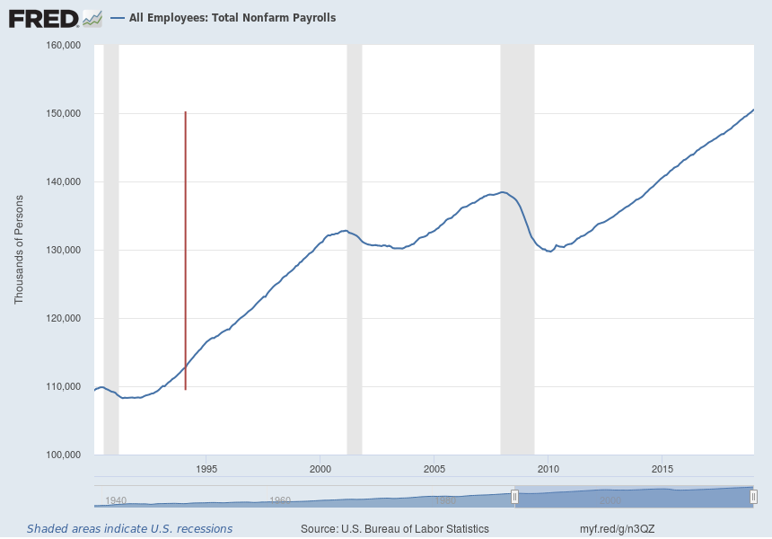
https://fred.stlouisfed.org/graph/?g=n3QV
Bureau of Labor Statistics data. Compiled for the FTE by Dr. Jamie Wagner Economics Professor and Director, UNO Center for Economic Education, University of Nebraska at Omaha

- In addition, the US unemployment rate has remained lower than pre-NAFTA levels. While the 2007-2009 recession caused unemployment to rise sharply that can hardly be attributed to NAFTA.
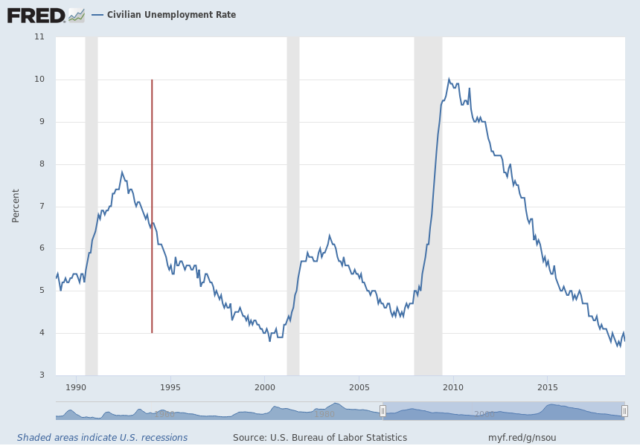
https://fred.stlouisfed.org/graph/?g=n3Ry
Bureau of Labor Statistics data. Compiled for the FTE by Dr. Jamie Wagner Economics Professor and Director, UNO Center for Economic Education, University of Nebraska at Omaha
- NAFTA clearly did not cause the “giant sucking sound” as jobs did not leave the US in droves as shown by the total number of jobs and unemployment rate.
- Does increased trade with Mexico lower the wages of workers in the manufacturing sectors of the United States economy?
- Free market analysis would suggest that free trade lowers the prices of goods ― and therefore, wages ― in import-competing industries.
- Since Mexican imports are primarily simple manufactured goods, if there had been a NAFTA-related decrease in wages, it would have be in the manufactured goods sectors.
- Production workers in all industries have seen mostly static real wages since 1990.
  - It is worth noting, however, that wages in manufacturing have been growing faster than in goods-producing industries, but it is not clear whether this is due to shifts in demand (as discussed above) or to globalization.
- The solution to understanding declining wages, then, is to ask why prices in such things as housing and health services have gone up so much, rather than to blame trade with Mexico.
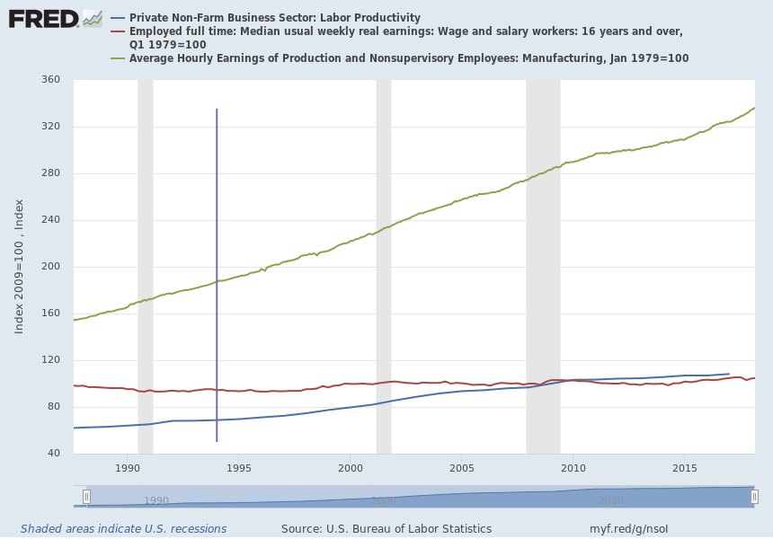

https://fred.stlouisfed.org/graph/?g=n3PJ
Bureau of Labor Statistics data. Compiled for the FTE by Dr. Jamie Wagner Economics Professor and Director, UNO Center for Economic Education, University of Nebraska at Omaha

- Wages are a function of labor productivity, not of global competition. (See Visual #4)
- Worker productivity is determined by a variety of factors, including:
    - Nature of human capital – skill, experience, and knowledge;
    - Investment in capital equipment;
    - Technology; and
    - Infrastructure.
- There is no consensus among economists as to whether trade plays any role in determining wage levels.

- Some economists believe this is due to skill-biased technological changes in manufacturing that have reduced the marginal product of labor, while others believe it is due to globalization. Either explanation points to forces larger and more encompassing than NAFTA.

  - Does increased trade with Mexico lead to larger trade deficits and a flow of investment out of the U.S.?

- It is impossible for the U.S. to run a trade deficit and have the “giant sucking sound” of investment leaving the U.S. at the same time.

- Basic balance of payments accounting (See Lesson 6) recognizes that the sum of the current account (goods and services) and the capital account (investment flows) must be 0.

- Thus, if the U.S. runs a trade deficit with Mexico (importing more goods and services than we export), we must run a capital account surplus, meaning that Mexico must be investing in the U.S. rather than the other way around, as Perot feared.
        - The data bear out the prediction: Except for a brief period in 1994, the U.S has run a trade deficit with Mexico and more capital has been moving from Mexico to the U.S. than from the U.S. to Mexico. (In other words, the “giant sucking sound” is occurring north, not south, of the border.)
- As concerns the trade deficit itself, it appears that trade with Mexico helped the current account situation, rather than hurting it.
- The U.S. trade deficit with Mexico is not a function of NAFTA but indicative of the overall pattern of the U.S. current account.
  - Canada and Mexico are the two largest markets in the world for US exports ($169 billion in 1994 to $645 billion in 2014). Total US trade with Canada and Mexico has increased by 296.9% between 1993-2014.
  - With regard to Canada and Mexico, the United States ran a cumulative trade surplus in manufactured goods of more than $79 billion over the past seven years (2008-2014). For services, the U.S. surplus was $41.8 billion in 2014 alone. The fact that substantial U.S. petroleum imports from Canada and Mexico contribute to the overall U.S. trade deficit stems from geology—not NAFTA. https://www.uschamber.com/report/the-facts-nafta-assessing-two-decades-gains-trade-growth-and-jobs
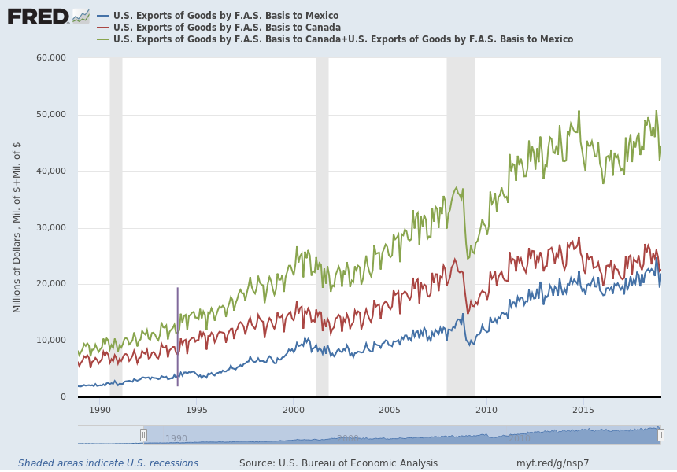
https://fred.stlouisfed.org/graph/?g=n42o
Bureau of Labor Statistics data. Compiled for the FTE by Dr. Jamie Wagner Economics Professor and Director, UNO Center for Economic Education, University of Nebraska at Omaha

US exports | 1993 | 2000 | 2014 | % change 1993-2014
To Canada - merchandise | 100,444 | 178,941 | 312,420 | 211.0%
To Canada – services | 17,016 | 24,613 | 62,946 | 269.9%
To Canada - merchandise | 117,460 | 203,554 | 375,366 | 219.6%
To Mexico - merchandise | 41,581 | 111,349 | 240,249 | 477.8%
To Mexico – services | 10,394 | 15,532 | 29,658 | 185.3%
To Mexico - merchandise | 51,975 | 126,881 | 269,907 | 419.3%
To both - merchandise | 142.025 | 290,290 | 552,669 | 289.1%
To both – services | 27.410 | 40,145 | 92,604 | 237.8%
Grand total exports | 169,435 | 330,435, | 645,273 | 280.8%
US Imports
From Canada - merchandise | 111,216 | 230,838 | 347,798 | 212.7%
From Canada – services | 9,106 | 17,875 | 30,579 | 235.8%
From Canada - merchandise | 120,323 | 248,713 | 378,377 | 214.5%
From Mexico - merchandise | 39,918 | 135,926 | 294,074 | 636.7%
From Mexico – services | 7,428 | 10,780 | 20,182 | 171.7%
From Mexico - merchandise | 47,345 | 146,706 | 314.256 | 563.8%
From both - merchandise | 151,134 | 366,765 | 641,872 | 324.7%
From both – services | 16,534 | 28,655 | 50,761 | 207.0%
Grand Total exports | 167,668 | 395,420 | 629,633 | 131.1%
Total Trade
With both-merchandise | 293,159 | 657,055 | 1,194,541 | 307.5%
With both-services | 43,944 | 68,800 | 143,365 | 226.2%
With Canada | 237,783 | 452,267 | 753,743 | 217.0%
With Mexico | 99,320 | 273,587 | 584,163 | 488.2%
Grand Total | 337,103 | 725,855 | 1,337,906 | 296.9%
Source: U.S. Census Bureau, Foreign Trade Division, and U.S. Department of Commerce, Bureau of Economic Analysis.
Millions of U.S. dollars
Statistical Comparison of NAFTA Countries, 1997
 | Population  (millions) | GDP  (billions U.S.$) | GDP  per capita | Exports  (billions $) | Imports  (billions $)
Canada | 30.3 | 625.6 | 19,640 | 213 | 196
Mexico | 94.3 | 402.5 | 3,700 | 110 | 110
U.S. | 267.6 | 8110.9 | 29,080 | 688 | 899

Statistical Comparison of NAFTA Countries, 2000

 | Population  (millions) | GDP  (billions U.S.$) | GDP  per capita | Exports  (billions $) | Imports  (billions $)
Canada | 30.7 | 689.5 | 22,459 | 278 | 249
Mexico | 98.0 | 574.5 | 5,860 | 166.4 | 174.4
U.S. | 281.6 | 9,882.8 | 35,095 | 782.4 | 1,258

Statistical Comparison of NAFTA Countries, 2005

 | Population  (millions) | GDP  (billions U.S.$) | GDP  per capita | Exports  (billions $) | Imports  (billions $)
Canada | 32.0 | 978.8 | 30,587 | 453.1 | 388.2
Mexico | 106.2 | 768.4 | 7,236 | 214.0 | 222.0
U.S. | 295.0 | 12,455 | 45,916 | 1,275 | 1,992

World Bank: http://web.worldbank.org/WBSITE/EXTERNAL/DATASTATISTICS/0,,contentMDK:20535285~menuPK:1192694~pagePK:64133150~piPK:64133175~theSitePK:239419,00.html (9/26/06)

Statistical Comparison of NAFTA Countries, 2017

 | Population  (millions) | GDP  (billions U.S.$) | GDP  per capita | Exports  (billions $) | Imports  (billions $)
Canada | 32.0 | 1,653 | 45,032 | 420.6 | 432.4
Mexico | 106.2 | 1,151 | 8,910 | 409.5 | 420.4
U.S. | 295.0 | 19,391 | 59,532 | 1,545.6 | 2,407.4

World Bank: http://web.worldbank.org/WBSITE/EXTERNAL/DATASTATISTICS/0,,contentMDK:20535285~menuPK:1192694~pagePK:64133150~piPK:64133175~theSitePK:239419,00.html 3/4/19)

Maquiladoras

year | # plants | Employment  (thousands) | Net exports  (millions)
1980 | 578 | 119.5 | $722
1982 | 585 | 127 | $851
1984 | 722 | 199.7 | $1155
1986 | 844 | 249.8 | $1295
1988 | 1441 | 369.5 | $2337
1990 | 1938 | 460.3 | $3611
1992 | 2075 | 505.0 | $4808
1994 | 2085 | 579.4 | $5944
1995 | 2104 | 639.9 | $4930
1996 | 2553 | 574.8 | $6429
1997 | 2717 | 898.7 | $8834
1998 | 2983 | 1008.0 | $10307

International Economics and International Economic Policy ed. by Philip King. New York: Irwin McGray-Hill, 2000: 178

.
U.S. Labor Force Conditions

Year | Total employment  (millions) | Number of unemployed  (millions) | Total labor force  (millions) | % unemployment
1990 | 118,793 | 7,047 | 125,840 | 5.6
1991 | 117,718 | 8,628 | 126,346 | 6.8
1992 | 118,492 | 9,613 | 128,105 | 7.5
1993 | 120,259 | 8,940 | 129,199 | 6.9
1994 | 123,060 | 7,996 | 131,056 | 6.1
1995 | 124,900 | 7,404 | 132,304 | 5.6
1996 | 126,708 | 7,236 | 133,944 | 5.4
1997 | 129,558 | 6,739 | 136,297 | 4.9
1998 | 131,463 | 6,210 | 137,673 | 4.5
1999 | 133,488 | 5,880 | 139,368 | 4.2
2000 | 136,891 | 5,692 | 142,583 | 4.0
2001 | 136,933 | 6,801 | 143,734 | 4.7
2002 | 136,485 | 8,378 | 144,863 | 5.8
2003 | 137,736 | 8,774 | 146,510 | 6.0
2004 | 139,252 | 8,149 | 147,401 | 5.5
2005 | 141,730 | 7,591 | 149,321 | 5.1
2006 | 144,427 | 7,001 | 151,428 | 4.6
2007 | 146,047 | 7,078 | 153,125 | 4.6
2008 | 145,362 | 8,924 | 154,286 | 5.8
2009 | 139,877 | 14,265 | 154,142 | 9.3
2010 | 139,064 | 14,825 | 153,889 | 9.6
2011 | 139,869 | 13,747 | 153,616 | 8.9
2012 | 142,469 | 12,506 | 154,975 | 8.1
2013 | 143,929 | 11,460 | 155,389 | 7.4
2014 | 146,305 | 9,617 | 155,922 | 6.2
2015 | 148,834 | 8,296 | 157,130 | 5.3
2016 | 151,436 | 7,751 | 159,187 | 4.9
2017 | 153,337 | 6,982 | 160,319 | 4.4
2018 | 155,761 | 6,314 | 162,075 | 3.9

Bureau of Labor Statistics CPS Employment Status: https://www.bls.gov/cps/tables.htm#empstat (3/25/19)

Indicators of Hourly Labor Costs For Production Workers in Manufacturing
Selected Countries
 | Labor Costs in $U.S. |  |  |  | Labor Costs in % of U.S. Labor Costs
 | 1996 | 1999 | 2005 | 2012 | 1996 | 1999 | 2005 | 2012
United States | 17.74 | 19.2 | 22.87 | 35.67 | 100% | 100% | 100% | 100%
Canada | 16.66 | 15.6 | 21.42 | 36.59 | 94% | 81% | 94% | 103%
France | 19.34 | 17.98 | 23.89 | 39.81 | 109% | 94% | 104% | 112%
Germany | 31.87 | 26.93 | 32.53 | 45.79 | 180% | 140% | 142% | 128%
Italy | 18.08 | 16.6 | 20.48 | 34.18 | 102% | 86% | 90% | 96%
Japan | 21.04 | 20.89 | 21.9 | 35.34 | 119% | 109% | 96% | 99%
United Kingdom | 14.19 | 16.56 | 24.71 | 31.23 | 80% | 86% | 108% | 88%
Korea | 8.23 | 6.71 | 11.52 | 20.72 | 46% | 35% | 50% | 58%
Mexico | 1.5 | 2.12 | 2.5 | 6.36 | 8% | 11% | 11% | 18%
Singapore | 8.32 | 7.18 | 7.44 | 24.16 | 47% | 37% | 33% | 68%
Labor costs in other countries converted to U.S. dollars at the market exchange rate.
Labor costs include wages and fringe benefits.
Bureau of Labor Statistics: https://www.bls.gov/fls/ichcc.pdf (3/4/19)

https://www.fte.org/teachers/teacher-resources/voluntary-national-content-standards-in-economics/
https://www.uschamber.com/report/the-facts-nafta-assessing-two-decades-gains-trade-growth-and-jobs

